# 4. Comparing the pathfinding algorithms

To test the performance of both versions of the A* Algorithm, we ran each of them separately using approximately the same Goal position. The results were the following:

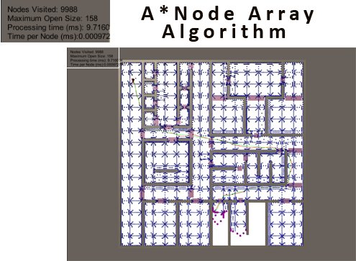

Image 4.1 – Result of A*Node Array Algorithm

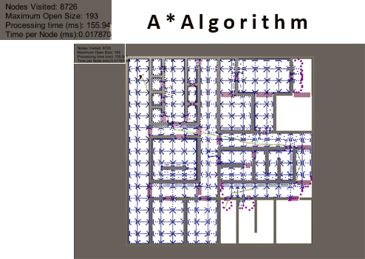

Image 4.2 – Result of A*Node Array Algorithm

The number of Nodes Visited and Maximum Open Size are very close between the two algorithms, and so we can dismiss the fill difference as irrelevant.

The processing time of the A* algorithm with Node Arrays is multiple times smaller than with unordered lists, and even though the number of Nodes Visited is higher in the Node Array version, the processing time per node is still much lower.

The faster processing time is a result of the much shorter seek time for any given node, which in turn makes the testing of its state much faster aswell. However, the Node Array A* algorithm must expend extra memory to store the pre-processed node graph.

So, in short, if you have the memory to expend and want faster processing time, the Node Array version of the A* algorithm is much better.